**ANSWERS FOR ASSINGMENT WEEK 1**

ANSWER 1

There are 2 major type of architecture in microprocessor and microcontrollers world .  
RISC stands for Reduced Instruction Set Computer and is a type of architectural processor design strategy.

The RISC architecture was developed with an eye to reducing complexity by using a simpler instruction set on processors that clock fewer cycles per second.

RISC is a Von Neumann type architecture. Von Neumann architectures can be categorized as the type that reads and executes one instruction at a time, which makes it possible to set up a predictable Pipeline of instructions.

Pipelining makes it easy for processing in parallel. RISC is used in embedded processors due to an instruction set that did not take up much space, its real-time processing capability, and low power consumption.

At the beginning there was a huge trade-off for memory and performance when RISC came into picture it brings memory efficient ways to process a instruction and faster processing.

ANSWER 2

It’s no wonder that everyone knowns what relay is in simple words a relay is switch an electronic switch that works electromechanically closing and opening its contract pad on the circuit board.

when a relay contact is normally open, there is an open contact when the relay is not energized. When a relay contact is Normally Closed, there is a closed contact when the relay is not energized. In either case, applying electrical current to the contacts will change their state.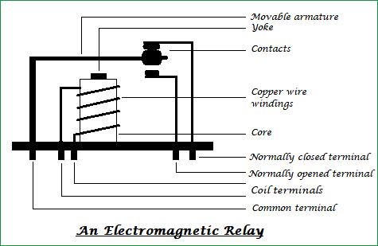

ANSWER 3

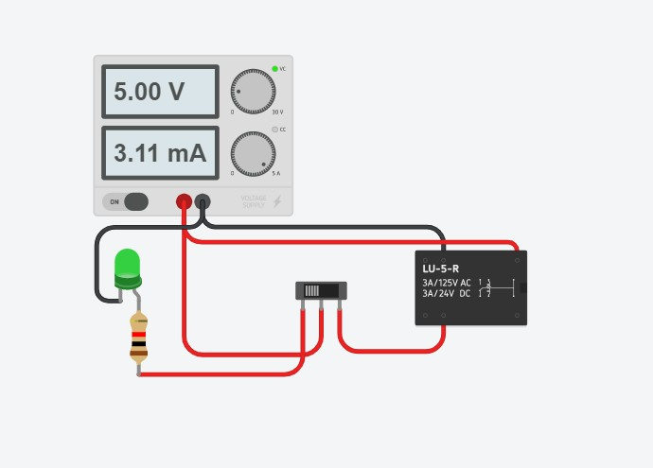

Relay circuit using as switch.

ANSWER 4  
  
According to the datasheet   
Max forward current(DC) = 50mA

Max voltage = 5V

Value of resistor is 58 ohms

Forward voltage of led (min) = 2.1V

Vr = 5 - 2.1 = 2.9V

Vr/I=R

2900/50=58

ANSWER 5

A Bridge rectifier is an Alternating Current (AC) to Direct Current (DC) converter that rectifies mains AC input to DC output. Bridge Rectifiers are widely used in power supplies that provide necessary DC voltage for the electronic components or devices. They can be constructed with four or more diodes or any other controlled solid-state switches. The first stage of the circuit is a transformer which is a step-down type that changes the amplitude of the input voltage. Next stage is a diode-bridge rectifier which uses four or more diodes depending on the type of bridge rectifier. Choosing a particular diode or any other switching device for a corresponding rectifier needs some considerations of the device like Peak Inverse Voltage It is responsible for producing unidirectional or DC current at the load by conducting a set of diodes for every half cycle of the input signal.

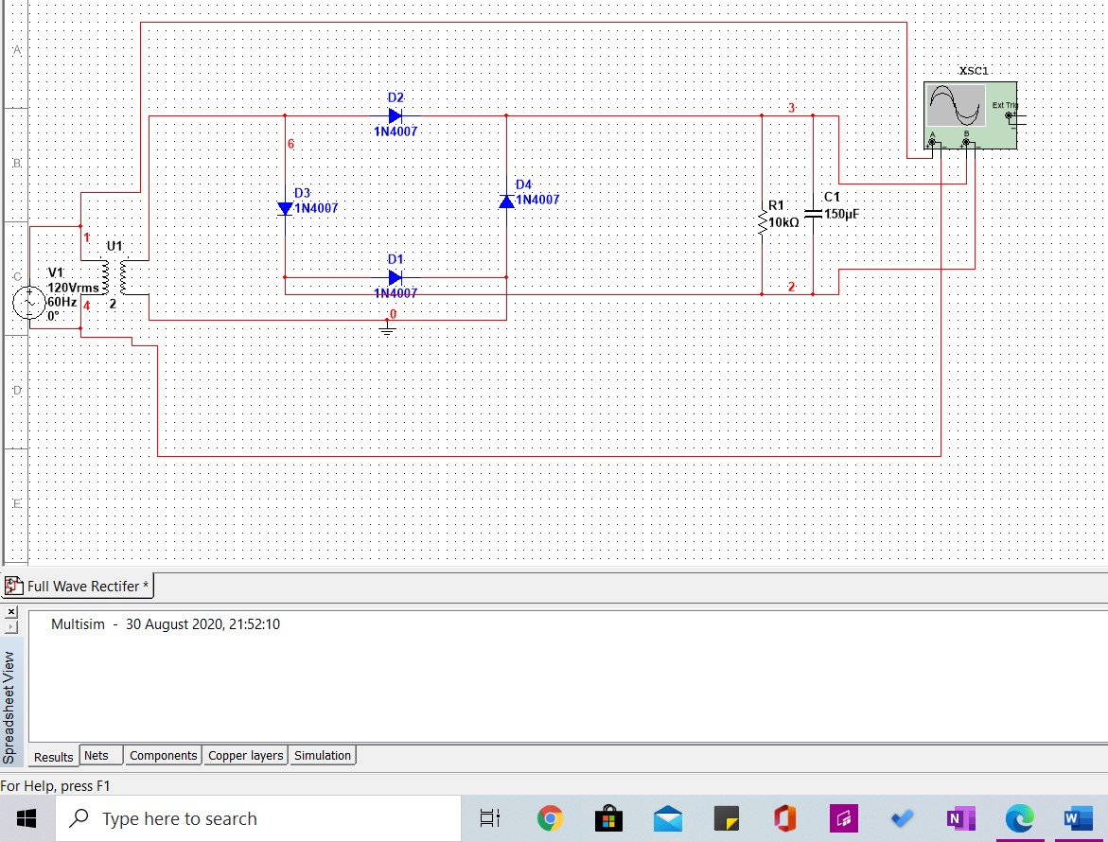

ANSWER 6

A bipolar junction transistor (BJT) can be used in many circuit configurations such as an amplifier, oscillator, filter, rectifier or just used as an on-off switch. If the transistor is biased into the linear region, it will operate as an amplifier or other linear circuit, if biased alternately in the saturation and cut-off regions, then it is being used as a switch, allowing current to flow or not to flow in other parts of the circuit

As you can see in figure 2 when voltage is below 0.7V(cut off ) of the npn bjt led doesn’t glow but where as in figure 1 led glows when voltage is set 0.7V this was the revolutionary idea a bjt using it as switch changed the world into a new kind .

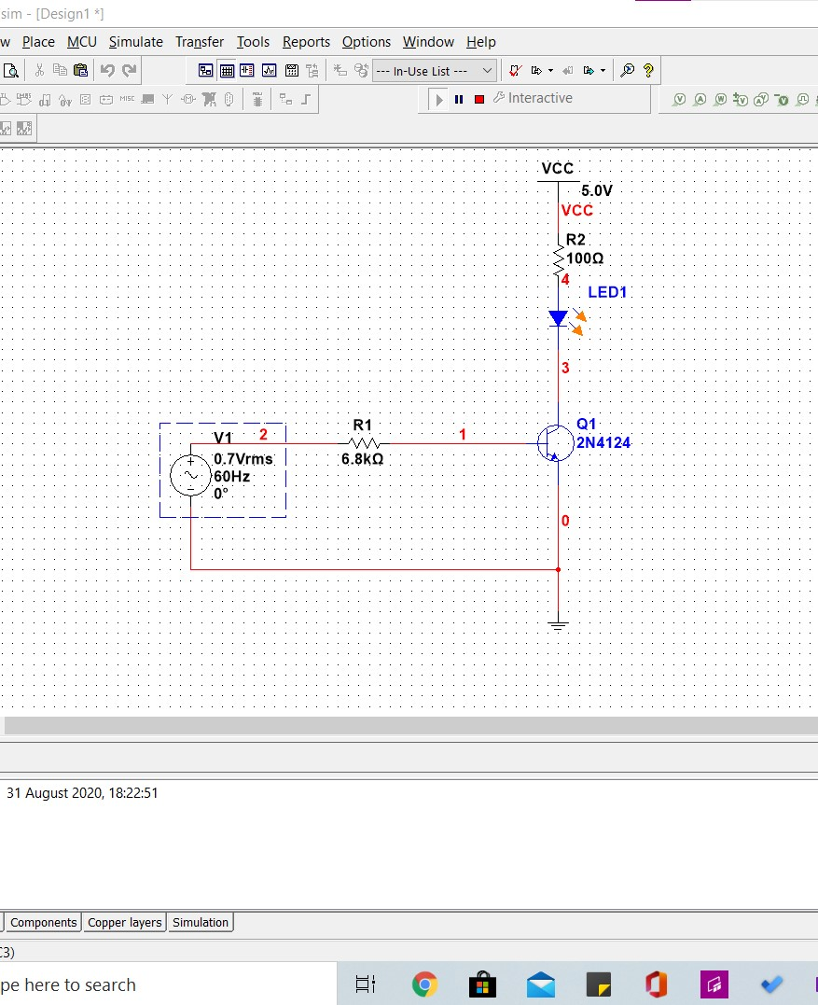

Figure1

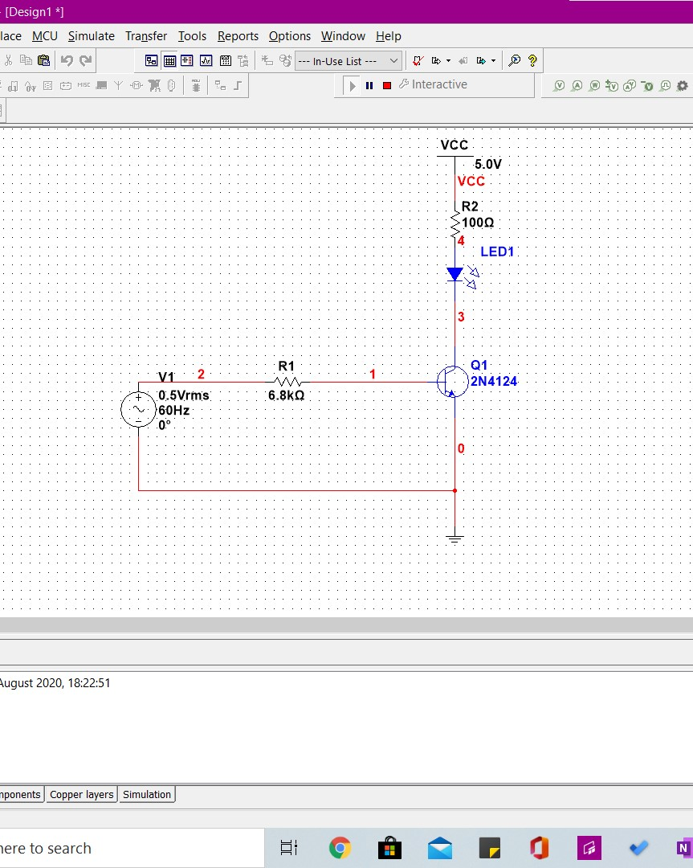

Figure 2

ANSWER 7

Voltage Divider Circuits are useful in providing different voltage levels from a common supply voltage. Voltage dividers are also known as potential dividers, because its the amount of potential difference between two points. A voltage or potential divider is a simple passive circuit that takes advantage of the effect of voltages being dropped across components which are connected in series. The potentiometer, which is a variable resistor with a sliding contact, is the most basic example of a voltage divider. (kvl)

VR1 =I*R1

&

VR2 =I*R2

Vs= I*R1 + I*R2

Vs= I * (R1+R2)

I = Vs/(R1+R2)

Since current is common in both the resistors

IR1 = VR1/R1=Vs/(R1+R2)

VR1 = Vs ( R1/R1+R2)

Similarly   
VR2 = Vs ( R2 / R1+R2)

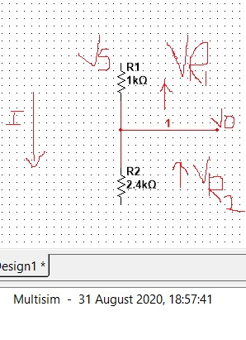

Example:-

Q) How much current will flow through a 1kΩ resistor connected in series with a 2.4kΩ resistor when the supply voltage across the series combination is 12 volts dc. Also calculate the voltage drop produced across each resistor.

A) total resistance

R= R1+R2= 3.4k

Total current

I = Vs/R = 0.0035 mA

VR1 = I*R1= Vs(R1/R1+R2)=3.48V

VR2 = I*R2= Vs(R2/R1+R2)=40.8V

ANSWER 8

High impedance or High-Z or Hi-Z is a state when the output is not driven by the input(s), that means output is neither high (1) nor low (0). The output is electrically disconnected from the circuit. It is used in buses, when you want to transfer more than one signal through same wire without the loss of data. Another application of Hi-Z state is in multiplexing.

ANSWER 9

R=2V/2I=V/I.

Resistance does not change   
Resistance is independent of the voltage and the current through the circuit.

ANSWER 10

Option A current will be the same through the all 3 resistors.